Q1. Examine the **FOUR (4)** basic process involved in the Network Layer to accomplish end-to- end communication. *(201603 TAR UC, resit)* (8 marks)

* Addessing: Identify IP address for each packets
* Encapsulation: Bundles the segments together with the IP header to allow for transmission.
* Decapsulation: Extract the segments out of received packets for the upper layers to process.
* Routing: Figure out the routes to take for the transmission of frames.

Q2. Differentiate between encapsulation process and de-encapsulation process used in the network layer. *(201703 TAR UC, resit)* (4 marks)

* Encapsulation adds the IP header to the segment to form a packet to be processed by the lower layers. De-encapsulation strips the IP header off the packet to form a segment to be processed by the higher layers.
* Encapsulation adds more information, decapsulation reduces the amount of information.

Q3. List and briefly describe **THREE (3)** characteristics of Internet Protocol Version 4 (IPv4).

*(201705 TAR UC, resit)* (6 marks)

* Best effort: No overhead to guarantee delivery.
* Media Independent. Operates independently of the medium. Can work regardless of what media is being used.
* Connectionless. No connection is established before sending data.

Q4. Internet Protocol version 4 (IPv4) is the most widely used version of Internet Protocol.

1. Briefly explain **TWO (2)** limitations of Internet Protocol version 4 (IPv4).

*(201509 TAR UC, Main)* (4 marks)

* *IP Address Depletion. Insufficient unique public IP address for all computers.*
* *Lack of end-to-end conectivity. Ipv4 uses Network Address Translation (NAT) which hides multiple computers behind single public IP. This causes problem for services requiring end-to-end connectivity as the device do not have its own public IP.*

1. IPv6 overcomes the limitations of IPv4. List **TWO (2)** improvements that IPv6 provides. (2 marks)
   * Increased address space.
   * Eliminate NAT.

Q5. With reference to Figure 1, answer the following questions:

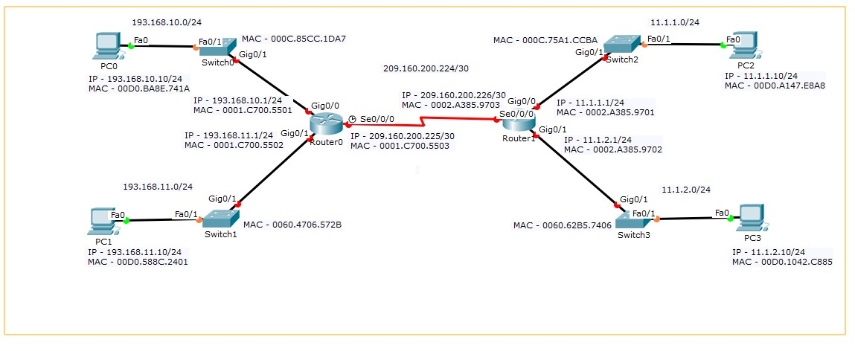

Figure 1: Main Campus Network

1. In Figure 1, locate directly connected routes and remote routes for Router 1.

*(201609 TAR UC, Main)* (5 marks)

|  |  |  |
| --- | --- | --- |
|  | **Directly Connected Routes** | **Remote Routes** |
| **Router 1** | 209.160.200.224/30 | 193.168.10.0/24 |
| 11.11.11.0/24 | 193.168.11.0/24 |
| 11.1.2.0/24 |  |

1. Using the table format given below, write the Layer 2 and Layer 3 addresses when PC0 ping to PC3. Add more rows to Table 1, if necessary.

*(201609 TAR UC, Main)* (6 marks)

CHECK WITH LECTURER

|  |  |  |  |  |
| --- | --- | --- | --- | --- |
| Step | Layer 2 source address | Layer 2 destination address | Layer 3 source address | Layer 3 destination address |
| PC0 pass frames to Switch0 | 00D0.BA8E.741A | 0060.4706.572B | 193.168.11.10/24 | 11.1.2.10/24 |
| Switch0 pass frames to Router0 | 0060.4706.572B | 0001.C700.5503 | 193.168.11.10/24 | 11.1.2.10/24 |
| Router0 pass frames to Router 1 | 0001.C700.5503 | 0002.A385.9703 | 193.168.11.10/24 | 11.1.2.10/24 |
| Router 1 pass frames to Switch3 | 0002.A385.9702 | 0060.62B5.7406 | 193.168.11.10/24 | 11.1.2.10/24 |
| Switch3 pass frames to PC3 | 0060.62B5.7406 | 00D0.1042.C885 | 193.168.11.10/24 | 11.1.2.10/24 |

Q6. Based on the diagram shown in Figure 3, identify the remote network and next hop address for the respective network for Router 1 and Router 2. *(201509 TAR UC, Main)* (6 marks)

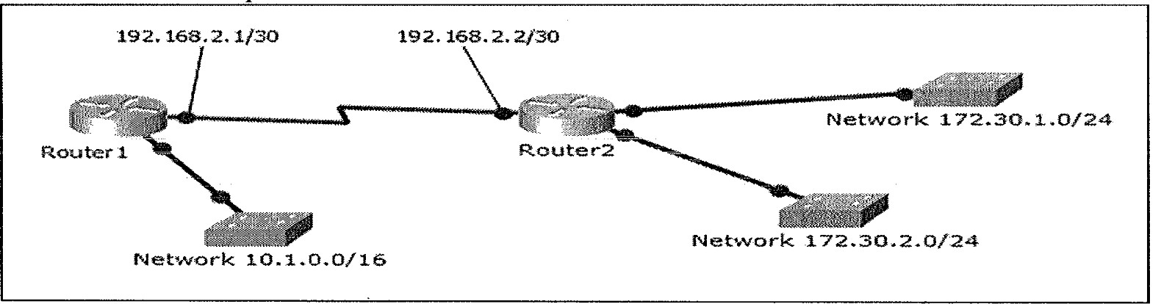

Figure 3: Network Topology Diagram

Router 1:

* Remote network & Next-hop address
  + 172.30.1.0/24 & 192.168.2.2/30
  + 172.30.2.0/24 & 192.168.2.2/30

|  |  |  |
| --- | --- | --- |
|  | Router network | Next-hop address |
| Router1 | 172.30.1.0/24 | 192.168.2.2/30 |
|  | 172.30.2.0/24 | 192.168.2.2/30 |
| Router2 | 10.1.0.0/16 | 192.168.2.1/30 |

Q7. Differentiate between physical address and logical address. *(201509 TAR UC, Main)* (4 marks)

|  |  |
| --- | --- |
| Physical Address | Logical address |
| Unique address across the world | Unique address in local network |
| Assigned by manufacturer | Assigned by router |

Q8. Choose **ONE (1)** type of memory which can be found in a router and briefly explain **ONE (1)**

function for each. *(201509 TAR UC, Main)* (2 marks)

* RAM. To temporarily store Address Resolution Protocol (ARP) table.

Q9. List **TWO (2)** files that a Cisco router stores in its compact flash card. *(201503 TAR UC, resit)*

(2 marks)

* Router IOS
* Configuration files

Q10. With reference to Figure 2, answer the following questions:

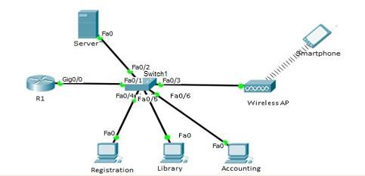

Figure 2: A branch network

1. In Figure 2, identify the default gateway for Server and Smartphone. Indicate the device name and the interface clearly in your answer. *(201605 TAR UC, resit)* (4 marks)
   1. Server: R1, Gig0/0
   2. Smartphone: R1, Gig0/0

(ii) “*When Registration PC wants to send a message to Library PC, it is not required to configure default gateway in both PCs.*”

Do you agree with the above statement? Justify your answer. *(201605 TAR UC, resit)*

(7 marks)

I agree with the statement. Registration PC and Library PC are located in the same local network. For local network delivery, the message is not required to be sent to default gateway. Switch will forward the message based on destination MAC address.

Q11. Network Layer provides services to allow end devices to exchange data across the network.

1. Examine **FOUR (4)** basic processes used in the network layer to accomplish end-to- end communication. (8 marks)

* Addressing: The network layer must provide a mechanism for addressing the end devices.
* Encapsulation: The network layer must provide encapsulation. The packets must contain the identified device address.
* Routing: The network layer must provide service to direct these packets to their destination.
* Decapsulation: Network protocols must specify the packet structure and processing used to carry the data host from one host to another.

1. Describe **THREE (3)** characteristics of Internet Protocol Version 4 (IPv4). (6 marks)

* Best effort: No overhead to guarantee delivery.
* Media Independent. Operates independently of the medium. Can work regardless of what media is being used.
* Connectionless. No connection is established before sending data.

1. Identify the Protocol Data Unit (PDU) of network layer. (2 marks)

* PDU for network layer is a **packet**.

1. Give **FOUR (4)** examples of the information contained in the PDU of network layer.

(4 marks)

* Source address, destination address, protocol, time-to-live (TTL)

Q12. Figure 4 shows the network topology diagram of Sunrise Ltd.

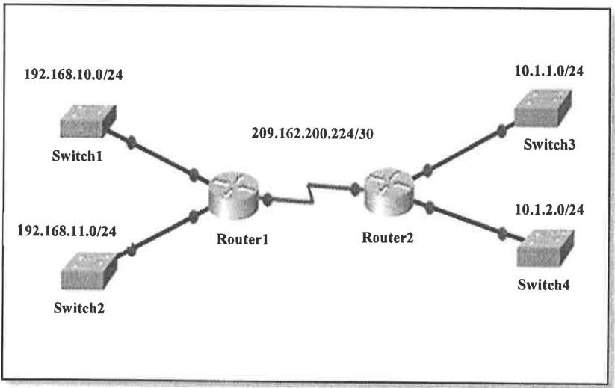

Figure 4: Network Topology Diagram

Based on the diagram shown in Figure 4, locate directly connected routes and remote routes for Router 1. (*201709 TAR UC Main)* (5 marks)

|  |  |  |
| --- | --- | --- |
|  | **Directly Connected Routes** | **Remote Routes** |
| **Router 1** | 192.168.10.0/24 | 10.1.1.0/24 |
| 192.168.11.0/24 | 10.1.2.0/24 |
| 209.162.200.224/30 |  |